小学英语资格面试—《Read and Write》教案
一、教学内容及教学目标
1. Read and write 内容分析
Read and write 分为读、写和语音三部分：第一部分要求学生填写出自己和同桌的爱好，并阅读公告栏的四则广告;第二部分为有意义的写句子活动，分两个步骤：第一步回答问题，仿写句子;第二步选择恰当的动词形式补全广告;第三部分为语音意识培养，选取阅读文段中的典型例子示范单词在句子中重读、弱读的朗读技巧。
2. 本部分的教学目标
通过讨论活动激活学生的背景知识及储备词汇;通过读后问题培养学生在语篇中捕捉不同类型信息的能力;根据阅读所获取的信息完成有意义的仿写活动;根据示例在文段中找到更多单词重读、弱读现象，最终正确朗读句子。
二、教学重难点
重点：运用略读(skimming)及扫读(scanning)的阅读技巧捕捉文本主旨及细节信息，解决问题。
难点：动词第三人称单数形式的运用。
三、教学步骤：
I. Lead-in
1. Greeting
2. Pair work. Students ask and answer questions about their hobbies and fill in two tables.
【设计意图】师生英语对话，营造宽松、愉快的英语学习环境，同时导入话题hobby,通过结对活动复习本单元前四课时所学句型，为本课学习做铺垫。
3. Group work and assessment
Teacher hands out six envelops with different names of clubs on it. There are many information pictures about the club in the envelope. Each group draws lots to decide which group they join in.
【设计意图】通过分组成立俱乐部形成课堂评价方，激发学生的学习兴趣，提高学习积极性，活跃课堂气氛，同时为课堂课堂创设真实情景，为后面的任务做好铺垫。
II. Pre-reading
Teacher asks student questions on how to have more students in each club so as to elicit the topic “ad writing”.
T: Now, you are in different club. Do you want to have more students in your club? But how can you do that? Yes, you can write an ad for your club. Do you know how to write an ad? Can you guess what should be in an ad? Now discuss in your groups.
【设计意图】明确课堂任务，进一步激发学生的学习欲望。阅读文本内容之前进行预测，培养学生的思维能力，为文本理解做好铺垫。
III. While-reading
1. Listen and read titles.听读标题，确定俱乐部。
T: Let’s read some ads together, and then you’ll know how to write one. Look at this notice board. Now listen and repeat the title of each and find out the names of the clubs.
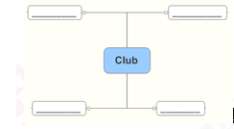
【设计意图】通过仔细阅读、分析标题可以得到一些关键信息。引导学生阅读标题，通过简单的几个词获取广告的关键信息，为进一步理解广告内容打好基础。
2. Scanning
Scan the text to find hobbies of each character in the ad and then check the answer together.
T: Now read for the second time. Find and write down their hobbies.
Amy likes ______________.
John _______.
Mike____________.
Robin___________.
【设计意图】培养学生在阅读时运用scanning的技巧，根据题目中的关键词在广告中查找相关信息，理解并归纳整理信息，填写出所需要的内容，培养学生的归纳能力。
3. Careful reading精读广告，查找关键信息
T: Read the ads carefully, and underline the detailed information. Let’s read the first ad together. (学生阅读) Now read the other three ads and underline the details. (默读)
【设计意图】培养学生精读技巧，根据要求在文中仔细查找，获取信息。通过画线让学生一目了然地了解广告所应包括的信息，为后面的总结产出做好铺垫。
IV. Post-reading
1. Finish the ad
Teacher provides some ads and delete some key information, such as title, time, places, activities, contact information. Then students are asked to finish the ads and read together.
T: Now, boys and girls, look here. I’ve written an ad. Read it and tell me “Is it an ad?”
T: Why not?
T: Oh, yes. Can you add a title for it?
T: Anything more? Great! Let’s add the time.
【设计意图】通过师生共同完成广告，学生更直观地了解到关键信息在广告中的重要作用，为后面能够更顺利完成制作广告的任务做好铺垫。同时培养学生善于观察，勤于思考的习惯，加强学生综合理解运用语言的能力。
2. Summarize
Teacher summarizes key factors of an ad together with students and then write it on the blackboard.
T: So, what should be in the ad?
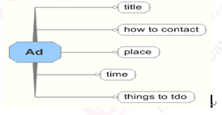
【设计意图】学生通过阅读广告以及补充广告信息这一系列的任务活动之后，可以用自己的语言总结出广告所应包含的内容。用思维导图呈现，思路清晰，为不全广告打好基础。
3. Write and present ads
Students work in groups and write ads for their groups.
T: Now can you write an ad for your group?
T: Now it’s your turn to write an ad for your club! You can use these stickers you get in the class to make your ads more beautiful. Is five minutes ok?
学生和同伴一起设计广告。评价方式中老师奖励的小图片学生可以用来装饰广告。学生完成后，教师将黑板布置成广告墙。学生贴上广告，以小组为单位读广告。每组完成后，老师请学生进行评价，并邀请学生课后邀请其他学生参观。
【设计意图】通过设置真实情景，让学生设计广告，将教材所学知识与实际生活紧密联系，实现灵活运用。最后的展示环节体现了广告的实际用途，让课堂任务有了更丰富的内涵。
V. Summary
Teacher summarizes and achieves emotion teaching goals.
T: You write great ads for your clubs. If you join a club, you can make more friends. Then you will be happy in your life.
VI. Homework
Write an ad for students’ clubs.
附课文原文：
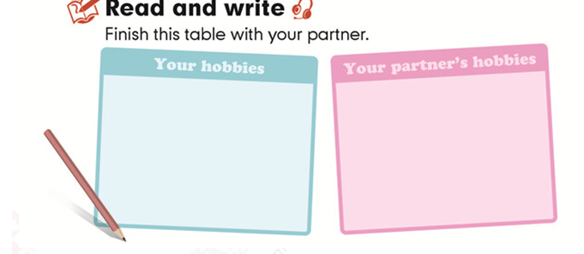
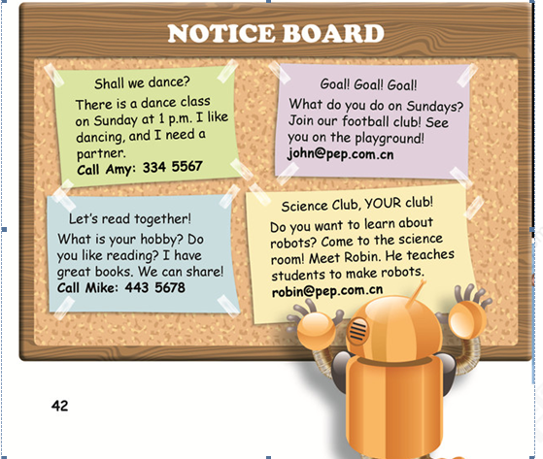
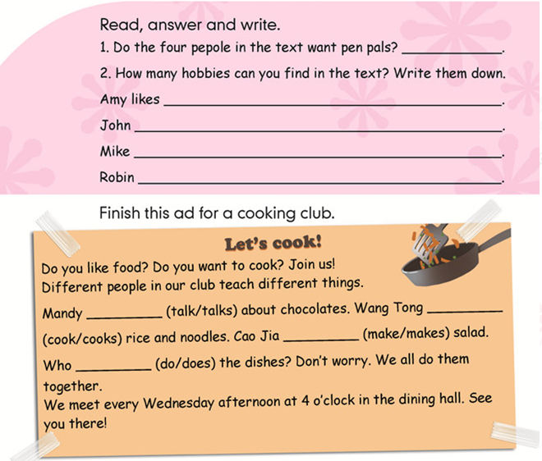
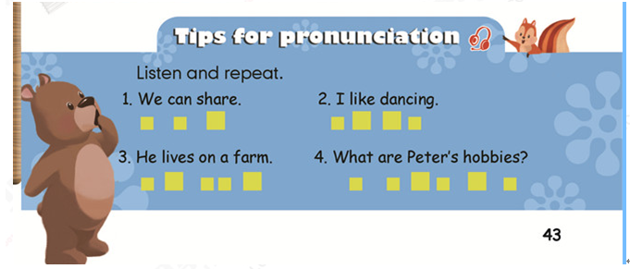

温馨提示：华图教师网(http://www.hteacher.net/)，微信公众号：htjiaoshi，教师招聘、教师资格证考试公告、备考资讯及时推送，更多精彩，欢迎订阅!

扫码关注微信公众号
售前电话：4006-01-9999
售后电话：010-8298221
资格证 QQ 群 ：248126741
教师招聘 QQ 群 ：600495464

